This is bad. Well good and bad. [Trevor Bauer](https://www.baseball-reference.com/players/b/bauertr01.shtml), the man I was pushing for a trade last season, has become a Dodger right after his historic (and possibly illegal) Cy Young victory. Not only that, but his short 3 year / $105 million is an absolute gem, offering a short term commitment while having a respectable AAV. This also means that for the next 2 years, Trevor Bauer will be the most paid player ($40 mil, $45 mil) in all of baseball, higher than [Mike Trout](https://www.baseball-reference.com/players/t/troutmi01.shtml), [Gerrit Cole](https://www.baseball-reference.com/players/c/colege01.shtml), and the [Baltimore Orioles](https://cdn.shopify.com/s/files/1/1133/3328/products/dumpster-2020_800x.jpg?v=1594250607). I’m not saying he’s not worth that money, but signing Bauer has led to some immediate problems for next season. Let's take a look.

Notable 2022 Free Agents

* [Clayton Kershaw](https://www.baseball-reference.com/players/k/kershcl01.shtml)
* [Corey Seager](https://www.baseball-reference.com/players/s/seageco01.shtml)
* [Kenley Jansen](https://www.baseball-reference.com/players/j/janseke01.shtml)
* [Chris Taylor](https://www.baseball-reference.com/players/t/tayloch03.shtml)
* [Corey Knebel](https://www.baseball-reference.com/players/k/knebeco01.shtml)
* [Joe Kelly](https://www.baseball-reference.com/players/k/kellyjo05.shtml) (Team Option)
* [AJ Pollock](https://www.baseball-reference.com/players/p/polloaj01.shtml) (Player Option)
* [Scott Kazmir](https://www.baseball-reference.com/players/k/kazmisc01.shtml) (Deferred Salary)

These players (and former player) make about $102 million in salary in 2021, and it's safe to say that players like Seager, Taylor, and Kershaw will be looking for more in free agency. Let’s start with the obvious cuts. Scott Kazmir hasn’t played professional ball since 2017, but has continued practicing with the Constellation Energy League, a Texas league that was created because of COVID. His heavy, deferred salary of $8 million a year will finally come to an end after this season and open up some tax space. AJ Pollock will be owed $23 million over 2 years if he stays with the Dodgers after 2021, probably more than any team will offer him so Pollock will most likely live out the rest of his contract in LA. Joe Kelly, the people’s champion, has a team option of $12 million in 2022, but unfortunately will probably be released. I would love to see Kelly come back on a cheaper contract, but he’ll find some other team to over pay him, but at least we got some great memes from him.

(insert joe kelly meme)

Corey Knebel is tricky because he’s still in arbitration this year, so his value can either rise or dip depending on this year’s performance. Should he blunder (knock on wood), he’d probably be released to free up more salary space. That leaves the best/hardest for last.

Chris Taylor (Utility)

CT3, my favorite player, signed a 2 year / $13.4 million extension in his last year of arbitration, making him a free agent in 2022. Originally a second baseman, the Dodgers converted him to an outfielder to replace then injured outfielder [Andrew Toles](https://www.baseball-reference.com/players/t/tolesan01.shtml), where he exploded onto the scene. In 2017, he hit .288/.354/.496 with 21 home runs while being named NLCS Co-MVP with [Justin Turner](https://www.baseball-reference.com/players/t/turneju01.shtml). He regressed a bit in 2018, leading the league in strikeouts, but still hit for average and was once again clutch in the NLCS against the Brewers with his game saving catch in Game 7.

(Link)

Since then he’s been a consistent batter who has flashes the leather every so often. Now the last utility man for the Dodgers will be a free agent in his age 31 season, and I’m not sure what to do with him. If he were to stay, he would have to split time in Left Field with AJ Pollock and at 2nd base with [Gavin Lux](https://www.baseball-reference.com/players/l/luxga01.shtml) (assuming he comes up by then). Taylor is getting older, and as a player that relies on his speed on offense and defense, his value is going to diminish. That being said, Utility players always have value and it wouldn’t be completely out there to resign him to another short term contract.

Prediction: 2 years / $15 million or Release in Free Agency

Kenley Jansen (Closer)

Despite his recent struggles, remember that Kenley is the Dodgers’ all-time saves leader and had a dominant stretch that rivaled [Eric Gagne](https://www.baseball-reference.com/players/g/gagneer01.shtml). Had it not been for his heart condition, there would be no debate that he was the best closer in franchise history. Unfortunately that didn’t happen. By no fault of his own, Jansen has not been at his best since his atrial fibrillation diagnosis that required heart surgery and regular medication.

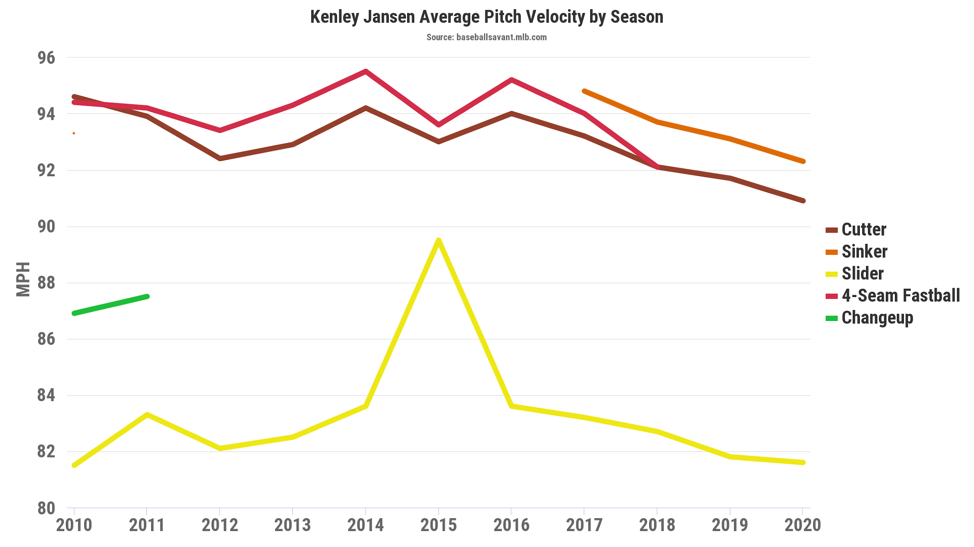

Since his 2017 dominance, all of Jansen’s pitches have been on the decline, especially his signature cutter dropping from 95mph to as low as 89mph last season. His numbers dipped significantly as a result, posting a mid 3 ERA over the last 3 years with a steadily increasing WHIP. It was bad enough to the point where Roberts deferred to [Blake Treinen](https://www.baseball-reference.com/players/t/treinbl01.shtml) and [Julio Urias](https://www.baseball-reference.com/players/u/uriasju01.shtml) to close games. Jansen is still one of the best closers in the league, but this is his contract year and regardless of how he does, I cannot imagine a future with him coming back. Should he regain his dominance, another team will overpay him in his age 34 season, and should he blunder, he’ll still be overpaid by another team. It would suck if he ends his tenure on a low note, but if he were to leave, he already set his place in Dodger history.

Prediction: Release in Free Agency

Clayton Kershaw

Prediction: X years / $XX million

Resign. End of story.

On the serious note, Kershaw resigning is a no brainer. Kershaw has never expressed interest in leaving nor has the franchise had problems paying him his worth in cash. Even in his degrading seasons he’s still one of the top pitchers in the league, once again posting a sub 3 ERA last season and finally getting rid of his postseason yips. You can even say he was clutch in the World Series. Unless Kershaw comes down with a serious injury (knocks on wood 2,000 times), Friedman will continue to offer him 2-3 year deals with an AAV of around $30 million. That sounds disrespectful, but Kershaw knows he’s going to stay so who cares if you contract isn’t long. He’s going to stay, and if he doesn’t it will seriously tarnish Friedman’s legacy.

Prediction: 3 years / $85 million

Corey Seager (Shortstop)

The reigning NLCS and World Series MVP has been put in a tough spot with the recent Trevor Bauer signing. Seager will be one of the most sought after free agents in 2022 and even though the Dodgers will try to sign an extension this season, Scott Boras is notorious for letting his clients dabble in free agency instead of committing midseason. Corey’s breakout season was always expected. The arguable best shortstop in Dodger history was on track to have a great 2018 season, but was sidelined with a UCL tear that needed Tommy John’s surgery, then was injured again in 2019 with a hamstring strain.

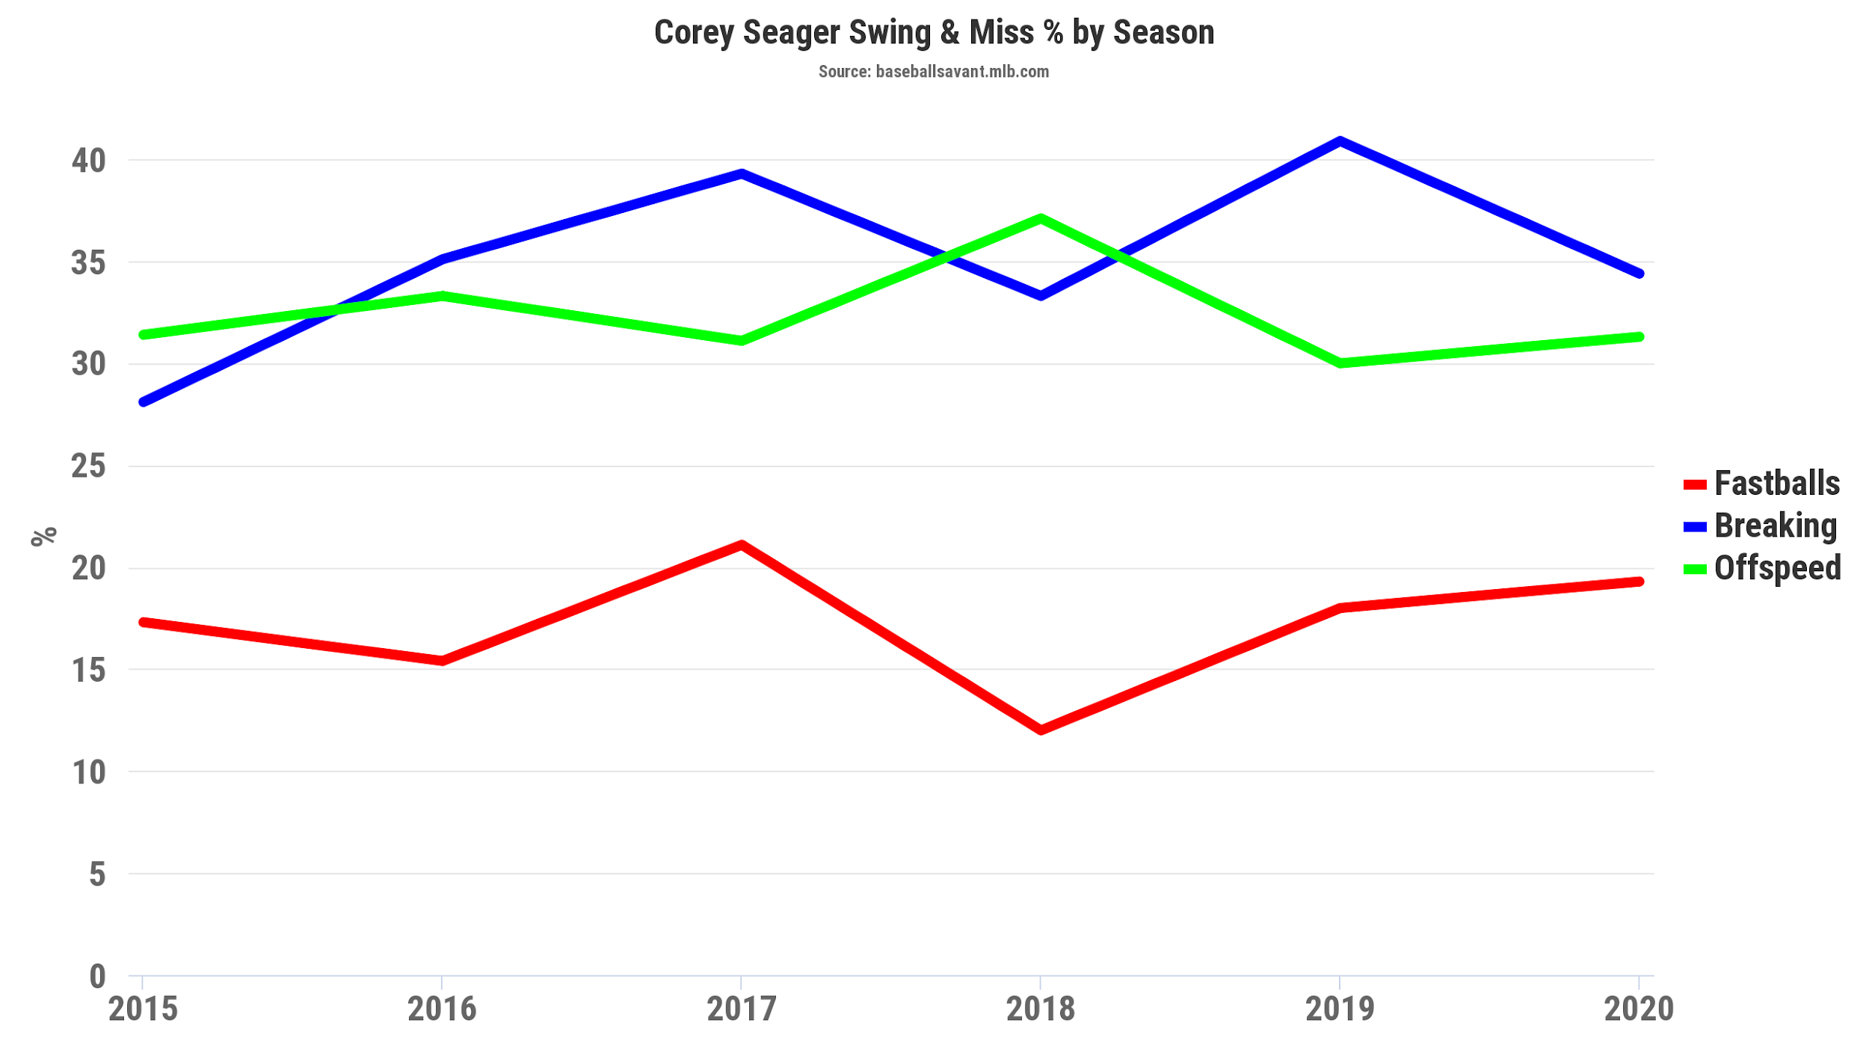

Seager was seeing the ball extremely well in 2018 before his injury, but understandably regressed in 2019 from being rusty. This past season showed a totally dominant Seager, dropping his Swing & Miss % by nearly 5% against breaking balls, his Achilles Heel the year before. Not only that, but a healthy Seager completely smashed the ball in 2020.

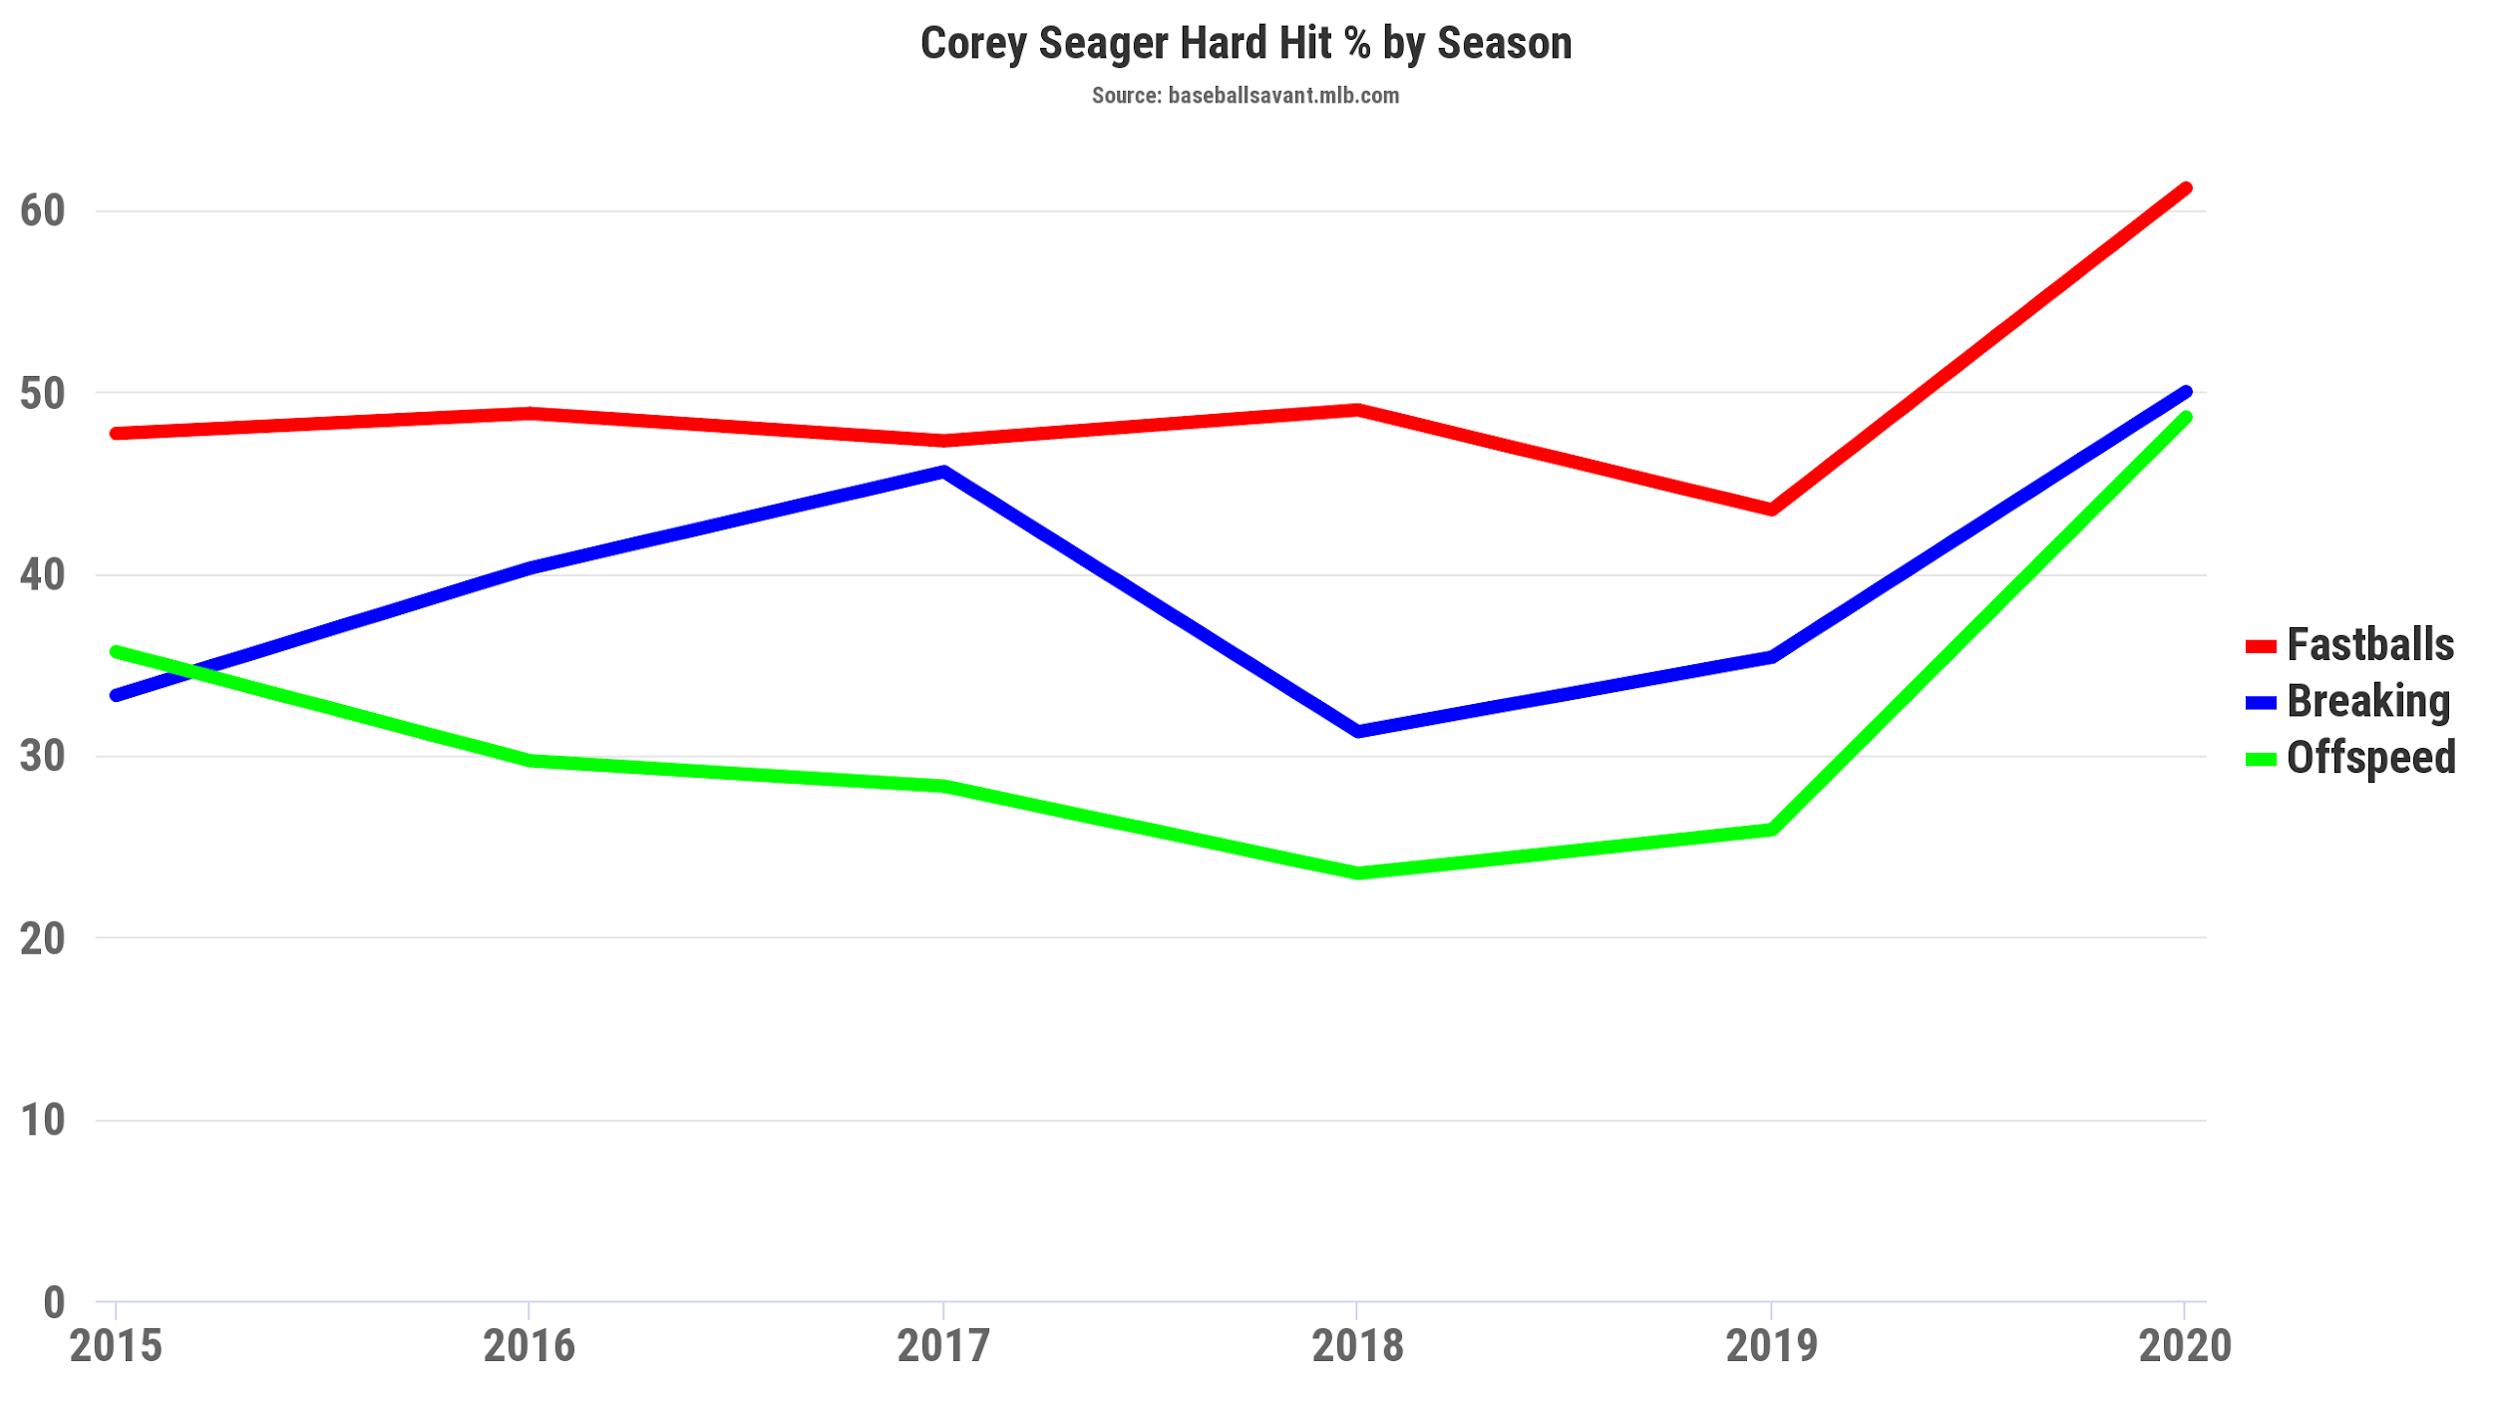

Seager’s contact and power ranked amongst the top 3 percentile in all of baseball. With this new eye and power, 2020 was entirely Corey’s year as he hit .307/.358/.585 for an OPS of .943. He somehow turned it up even more during the postseason and World Series, hitting a combined .358/.452/.714 for an OPS of 1.166. What an unreal beast. A healthy Seager is worth max contract money, but that depends on IF he’s healthy. The 2020 shortened season was the first complete season Seager played since his rookie 2016 season, and who knows if he would’ve been bit by the injury bug had 2020 been 162 games. Regardless, he is one of the best shortstops in the league and is completely worth the money. The problem lies with Friedman once again. If Seager were to resign at max money, it has the potential to put the Dodgers in debt until at least 2023 where Bauer’s contract would end (just in time for [Cody Bellinger](https://www.baseball-reference.com/players/b/bellico01.shtml)’s free agency). If you ask me, Seager is worth the tax, but it’s not my money to begin with. The Dodgers should be first choice for Seager if the price is right, but with Scott Boras anything is possible.

Prediction: 8 years / $220 million w/ Incentives + Player Option

Total Added Salary in 2022: ~$64 million

Trading David Price?

This is an option I’ll explore in a later article. Tl;dr, [David Price](https://www.baseball-reference.com/players/p/priceda01.shtml)’s expensive $32 million per year contract is a heavy load even with Boston deferring half of it. With other young starters like [Dustin May](https://www.baseball-reference.com/players/m/maydu01.shtml) and [Tony Gonsolin](https://www.baseball-reference.com/players/g/gonsoto01.shtml), it’s possible to offload his contract to open more space for our free agents.

#MyGutHasBeenWrongBefore